Fast**National University of Computer & Emerging Sciences, Karachi  
Fall-2023 FAST School of Computing  
Midterm-I**

**13th October 2023, 10:45 am – 12:45 am**

|  |  |  |
| --- | --- | --- |
| **Course Code:** | **Course Name:** | |
| **Instructor Name:** Mr. Ali Hasnain Ladhani | | |
| **Student Roll No:** | | **Section:** |

**Instructions:**

* Return the question paper and make sure to keep it inside your answer sheet.
* Read each question completely before answering it. There are **seven questions and two pages (front plus back)**.
* In case of any ambiguity, you may make assumption. However, your assumption should not contradict any statement in the question paper.
* Do not write anything on the question paper (except your ID and section).

**Total Time:** 2 Hour **Max Points**: 30

------------------------------------------------------------------------------------------------------------------------------------------------

**Question#1:** Differentiate between Windows and Linux **(2 marks)**

**Question#2:** Differentiate between local storage apps and cloud storage apps **(2 marks)**

**Question#3:** What is CPU **(1 marks)**

**Question 4:** Solve the following**:** **(5 marks)**

1. (1101001101)2 => Decimal **(0.5 marks)**

2. (110110110111111)2 => Hexa-Decimal **(0.5 marks)**

3. (D3EA) => Binary **(0.5 marks)**

4. (DA5A) => Decimal **(0.5 marks)**

5. (909.80)10 => Binary **(0.5 marks)**

6. Add 110011101000 & 11100111111 **(0.5 marks)**

7. subtract 1010111 from 1110101010 **(0.5 marks)**

8. multiply C2 with E5 and convert the result in binary **(1.5 marks)**

**Question#5:** attempt the following via commands **(10 marks)**

**Note:** screenshot each and every command

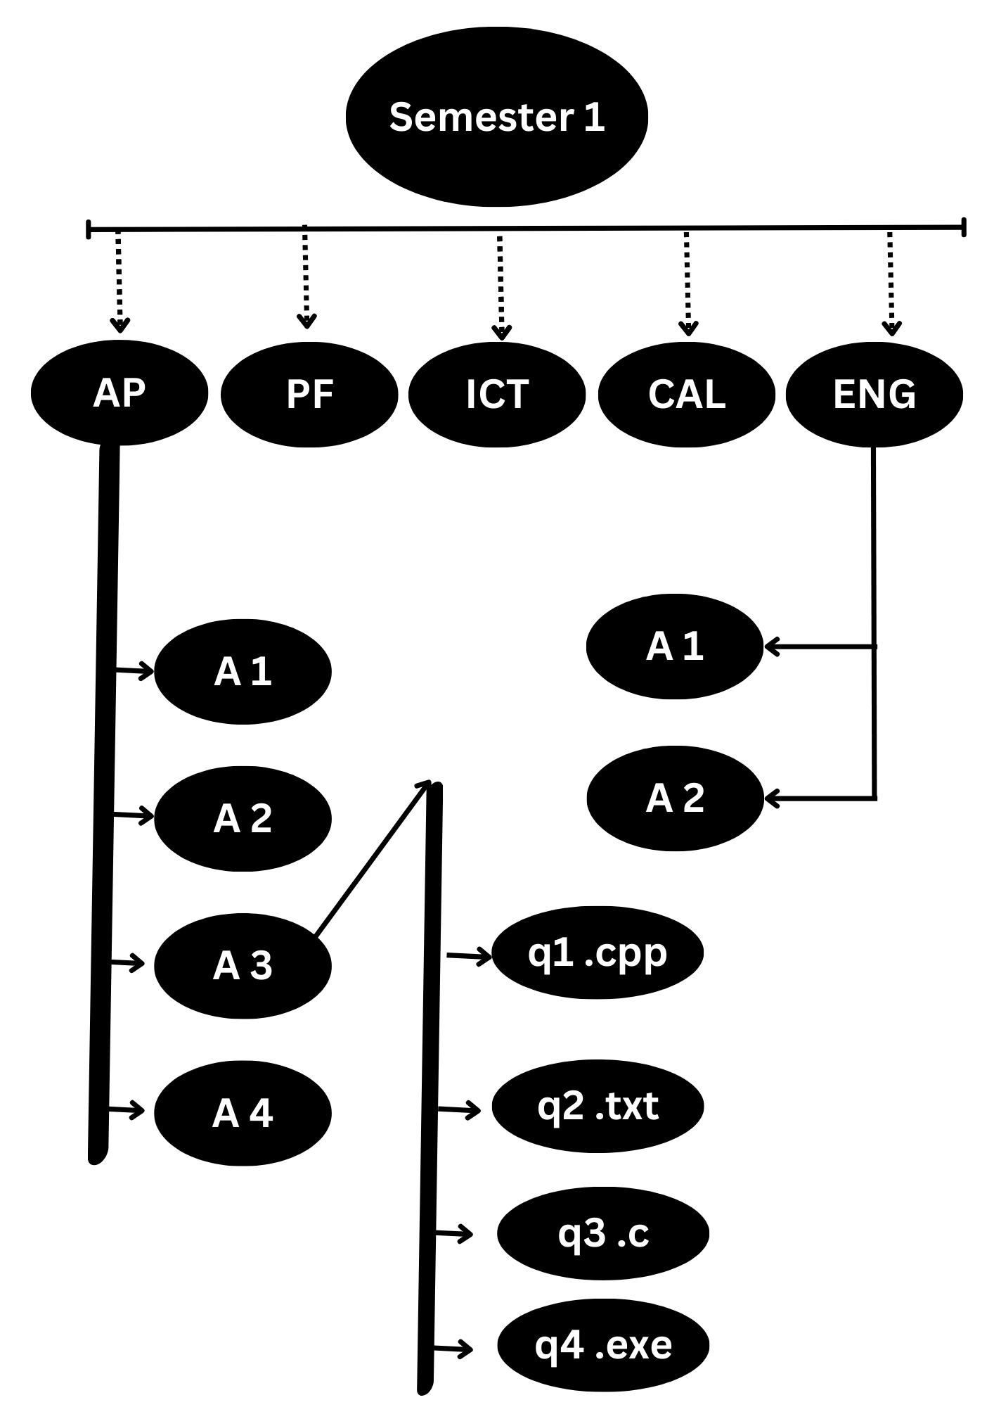a) create this tree **(5 marks)**

b) delete A3 of AP **(1 marks)**

c) populate all files with your first name & roll number **(2 marks)**

d) delete q3.c **(1 marks)**

e) go back to semester 1 via command one command only **(1 marks)**

**Question#6: Complete the following table via formulas (8 marks)**

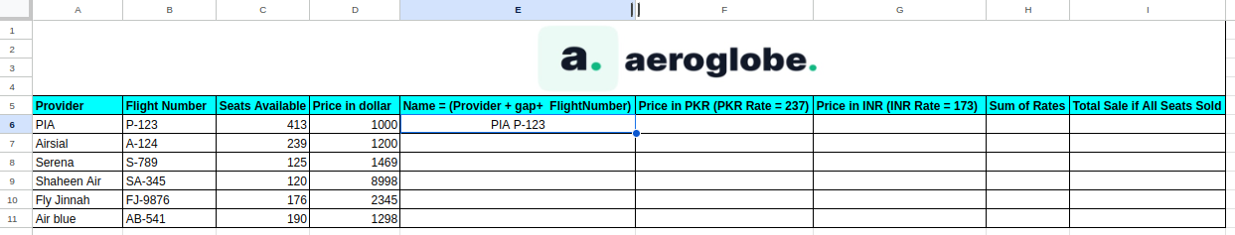**Question#7: submit the screen shots in a word file (2 marks)**

1) include borders

2) header = page number

3) footer = your name & roll number

4) alignment = right